More Evidence That Youthful Blood Can Reverse The Effects Of Aging

A few years ago, scientists from Stanford discovered that it's possible to reverse cognitive decline in old mice by injecting them with the blood of the young. Now, researchers have isolated the mechanism responsible for this rejuvenation — and it's a protein that's found in humans as well.

Could injecting yourself with blood of the young reverse the aging process?
It would appear that the Slovak-Hungarian "Blood Countess" Elizabeth Báthory may have been on to something: Researchers have shown that it is possible to reverse cognitive decline in old mice by injecting them with blood from the young. Elderly mice who were given transfusions of young blood were shown to exhibit improved learning skills and memory — and at a level comparable to much younger mice. Should the same effect apply to humans, it could represent a novel way to treat neurodegenerative disorders like Alzheimer's and Parkinson's.
A primary reason why we experience cognitive decline as we get older is due to our decreased production of neural stem cells — what ends up causing fewer connections between brain cells. Exercise has been known to help, but its effects are limited.
But Saul Villeda of Stanford University has shown that the production of these stem cells may have something to do with the quality of our blood.
He first made this discovery two years ago when he injected the blood of an older mouse into a younger one and vice versa. Villeda did this by connecting the circulatory systems of two mice so that their blood could mix (what's called heterochronic parabiosis). Soon after the transfusion he noticed that the younger mouse's brain started to age much more rapidly. And when he analyzed the older mouse, he observed that the number of stem cells had increased. His study led to a research paper that was later published in Nature.
More recently, Villeda's experiments have sought to determine whether or not this effect translates to behavioral changes as well. In the new study, he performed a similar transfusion and put the mice into a water maze where they were required to perform memory tasks. He discovered that the older mice did almost as well as mice who were four to six months old. As for the older, untreated mice, they made lots of mistakes and continually swam down blind alleys.
In terms of what's happening, the researchers say the young blood is likely reversing the aging process by topping up levels of key chemical factors that normally decline in the blood as we age. Speaking to the Guardian, Villeda noted that, after the transfusion, "all of a sudden you have all of these plasticity and learning and memory-related genes that are coming back." But as to which exact factors are causing the effect, the researchers are not sure — there are hundreds of thousands of candidate factors.
Looking ahead, Villeda says his team's insights could result in genuine rejuvenation therapies for people dealing with cognitive decline. The first step, however, is to determine whether or not this effect translates to humans.
Villeda presented these results at the annual meeting of the Society for Neuroscience in New Orleans on October 17, 2012. An earlier version of his research appeared in Nature last year.

And now, two new studies suggest he was on the right track.

Recharging Body and Brain
The independent research papers, one from Harvard and one from Stanford, are reporting that injections of a protein, or growth factor, known as GDF11 is capable of rejuvenating a number of seemingly unrelated physiological aspects.
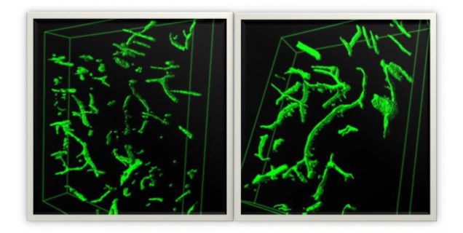
Above: Reconstructions of blood vessels in an old mouse's brain (left) and in an old mouse that received young mouse blood. Lida Katsimpardi.
The Harvard study, which now appears in Science, used the protein to improve the exercise capability and skeletal muscle function of mice (tests showed improvements in recovery from muscle injury, along with improved performance on running and grip strength tasks). The Stanford researchers showed that the transfusions encouraged the growth of new blood vessels and improved the function of the olfactory region of the brains of older mice, allowing them to detect smells just as well as younger mice. The injected mice were also shown to perform better on memory tests than mice of the same age that hadn't received the youthful blood plasma.
Previously, GDF11 was shown to make the failing hearts in aging mice appear more like those of young healthy mice.
As noted, humans have this protein, too. According to Amy Wagers and Lee Rubin of Harvard's Department of Stem Cell and Regenerative Biology (HSCRB), barring unexpected developments, they expect to have GDF11 in human clinical trials within three to five years. The goal is to develop interventions that treat neurodegnerative disorders such as Parkinson's and Alzheimer's.
In a prepared statement, HSCRB co-chair Doug Melton said that he couldn't
recall a more exciting finding to come from stem cell science and clever experiments. This should give us all hope for a healthier future. We all wonder why we were stronger and mentally more agile when young, and these two unusually exciting papers actually point to a possible answer: the higher levels of the protein GDF11 we have when young. There seems to be little question that, at least in animals, GDF11 has an amazing capacity to restore aging muscle and brain function.
It's definitely an amazing discovery — and the first example of a rejuvenation factor that's naturally produced by our own bodies, one that's capable of reversing (or slowing) aging in multiple tissues.

Restoring Stem Cell Function
Both research teams examined the effect of GDF11 in two ways. First, they created a parabiotic system in which two mice were surgically joined, so that the blood of the younger mouse could circulate through the older mouse. The second method involved direct injections of the protein into the older mice. Subsequent tests, along with comparisons to control groups, revealed the therapeutic effects of the procedure.
Previous studies have shown that GDF11 works by regulating and restoring stem cell activity. This protein is abundant in young organisms, but drops off as animals age. After the experiments, 3D reconstructions of the brain and fMRI scans showed more new blood vessels and more blood flow, both of which are normally associated with younger, healthier brain tissue.
The researchers speculate that GDF11 improves vascularity and blood flow, which is associated with increased brain re-growth.
"However, the increased blood flow should have more widespread effects on brain function," noted Rubin. "We do think that, at least in principle, there will be a way to reverse some of the cognitive decline that takes place during aging, perhaps even with a single protein. It could be that a molecule like GDF11, or GDF11 itself, could [reverse the damage of aging]."
Rubin says that a potential drug is not "out of the question."

Treating Humans
To date, the only other interventions known to reverse or slow aging have been caloric restriction, rapamycin, and the administration of nicotinamide mono nucleotide (NMN). But one of the primary advantages of GDF11 is that it's found naturally in the blood.

